RV-4 Baseline MPH IAS EFIS (1G ½ KT Deceleration Rate) Set Points
 | Flaps 0 | Flaps 20 | Flaps 40
L/D_{MAX} | 90 | 90 | 90
ONSPEED FAST | 77 (79) | 75 (75) | 74 (73)
ONSPEED SLOW | 69 (73) | 67 (69) | 66 (68)
Stall Warning | 63.5 | 60 | 59
Stall | 58.5 | 55 | 54
*Nominal Test Weight at 5K’ Pressure Altitude. BOW 1148 lbs no parachute. 1160 with parachute (not normally fitted). Add fuel on board (FOB) to BOW to determine test run gross weight. FOB recorded on FWD VIDEO only. Red font 1.25 – 1.35 Vs rounded up. V2 to IAS = .977+4.162.
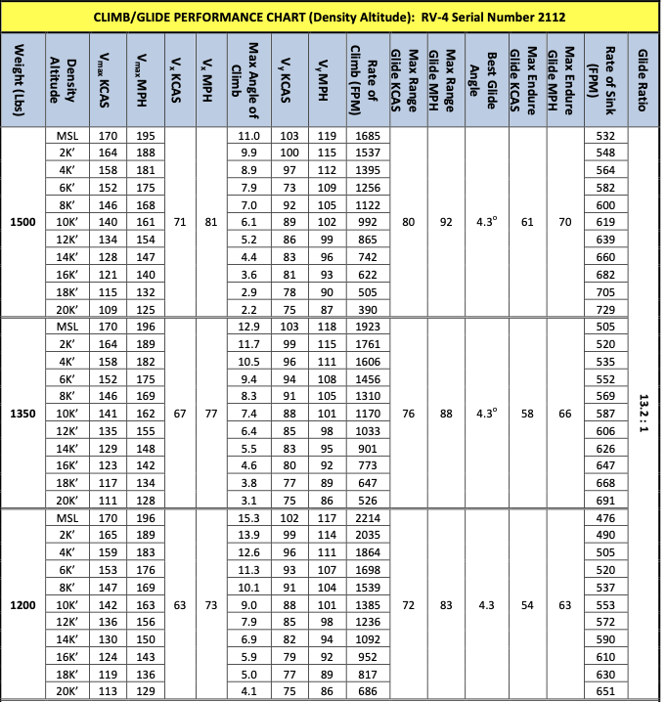

Gross Weight Look Up |  | Radio Freqs
FOB (Gal) | Weight (lbs) | Eglin ATIS | 134.625
30 | 1328 | CTAF | 122.9
28 | 1316 | North | 125.1
26 | 1304 | South | 132.1
24 | 1292 | Radar | 124.05
22 | 1280 | Eglin Twr | 118.2
20 | 1268 | Duke Twr | 133.2
18 | 1256 | Destin ATIS | 133.925
16 | 1244 | Destin Twr | 118.45
14 | 1232 | Destin Gnd | 121.6
12 | 1220 | CEW ASOS | 119.275
10 | 1208 | CEW CTAF | 122.95

Derived Alpha Trim Shot Cal |  | EFIS (VN-300) Auto Cal
Flaps 0 | Sensor 129 | Flaps 0 | Sensor 129
L/D | 5.45 (97.5) | L/D | 8.03
OS Fast | 9.33 (77) | OS Fast | 11.25
OS Slow | 11.6 (69) | OS Slow | 13.84
Stall | 14.3 (56.5) | Stall | 16.48
22.556x + 4.1106 |  | 8.4845x² + 24.0804x + 4.6157
Flaps 20 | Sensor 158 | Flaps 20 | Sensor 158
L/D | 3.70 (94) | L/D | 5.73
OS Fast | 7.03 (75.5) | OS Fast | 9.74
OS Slow | 10.0 (63) | OS Slow | 12.64
Stall | 14.01 (62) | Stall | 16.29
23.318x + 2.5496 |  | 4.5244x² + 27.9928x + 2.7661
Flaps 40 | Sensor 206 | Flaps 40 | Sensor 206
L/D | 2.17 (94) | L/D | 4.78
OS Fast | 5.77 (74.5) | OS Fast | 8.62
OS Slow | 8.69 (66) | OS Slow | 12.44
Stall | 12.47 (60.5) | Stall | 14.51
24.959 + 0.7909 |  | 1.2984x² + 30.4239x + 1.455

